

Essential Companion Scheme

We offer essential companion tickets for guests who require additional assistance during their visit, at no additional cost.
Please see our step-by-step guide below:

Step 1 – Deciding what tickets you need
We offer 3 different ticket types: CAMPING, WEEKEND, DAY
If you are unsure on what tickets to purchase, please visit our ticket guide on our FAQ page for more information and guidance:
What Tickets Do I Need?

Step 2 – Selecting your tickets
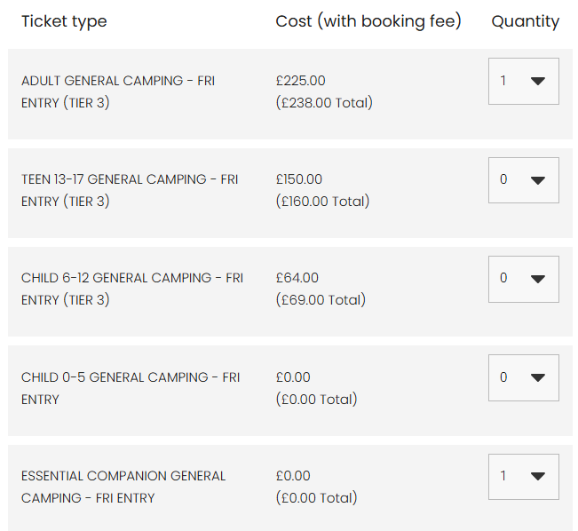
Everyone visiting Big Feastival will require an admission ticket into the event, including Essential Companion. Please add your Essential Companion ticket alongside the number of tickets you require.
Essential Companion tickets can only be purchased if there is an Adult ticket holder on the booking.

Our Access Campsite is a smaller area with additional accessible facilities. For further information please take a look at our FAQs HERE
To reserve a space in this area, please select your Access Camping / Live-In Vehicle tickets under the ‘Access Camping’ tab.



Step 3 – Upload your Documentation

On the checkout page, you will need to upload your documentation.
Examples of relevant documentation to support your essential companion request include:
- DLA (Disability Living Allowance)
- PIP (Personal Independence Payment)
- Evidence of registered severely sight impaired (blind)
- CredAbility Access Card (with +1 icon)
- Copy of Attendance Allowance letter
- Recognised Assistance Dog ID card
- Any other relevant documentation
All documents provided must show your full name and be dated from no older than 2022.

Step 4 – Your tickets

Your tickets will be issued via email a week prior to the event with the following layout:
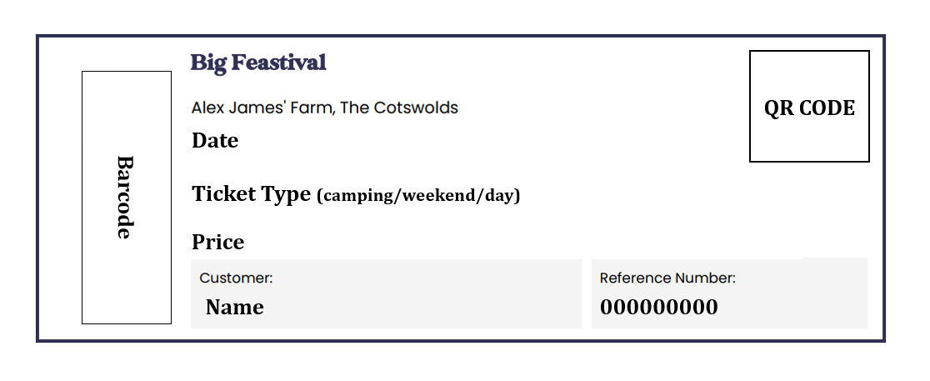

Step 5 – At the event

When you arrive at the entrance to the festival and have your tickets scanned, you will then receive your accessible wristband and your accessible lanyard.
You will then have access to all our accessible facilities. Please note you do not need to go to the Box Office to receive these passes.

Further information:
We offer Essential Companion tickets for guests who require additional assistance during their visit, at no additional cost.
For those with Child and Teen tickets, an Essential Companion ticket shall also be provided if required, at no additional cost, but the Child or Teen must be accompanied by a paying Adult ticket holder.
Please note: Bookings are limited to 1 Essential Companion ticket per Adult ticket. If you require 2-1 support and therefore require additional Essential Companion tickets, please contact See Tickets or the Big Feastival Customer Service Team.
At Big Feastival everyone in your party will need an admission ticket prior to arriving at the event. Please do be sure to select your Essential Companion ticket as well as your own if you require additional assistance whilst at the event.
You will need to provide your supporting documentation to support your Essential Companion ticket request once you have purchased your tickets. This will be requested by See Tickets.
If you do not have the relevant documentation or have any questions about your tickets, please contact us HERE

Please make sure you provide one of the below documentations to support your essential companion request:
- DLA (Disability Living Allowance)
- PIP (Personal Independence Payment)
- Evidence of registered severely sight impaired (blind)
- CredAbility Access Card (with +1 icon)
- Copy of Attendance Allowance letter
- Recognised Assistance Dog ID card
- Any other relevant documentation
All documents provided must show your full name and be dated from no older than 2022.
These tickets can be booked online via our website: https://thebigfeastival.com/tickets
Essential Companions attending through this scheme needs to be 18 years old by the start of the festival.
The above scheme and facilities are for customers with permanent/ long term access requirements and are not for people with temporary impairments such as broken bones, healing wounds or people who are pregnant.

Contact Details:
For any ticketing queries, please contact See Tickets HERE
For additional information about accessibility at the event, please see our Accessibility Guide HERE
For any other queries about the event, please contact our customer service team HERE

