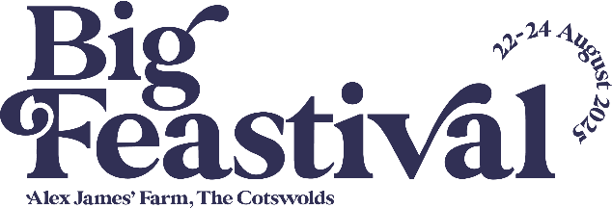

Ticket Guide
At Big Feastival we offer 3 different ticket types: CAMPING, WEEKEND, DAY
Unsure as to what ticket you need? Please see our ticket guide below to help ensure you have the correct tickets.

Camping Tickets
If you are looking to attend for the whole weekend and stay overnight at Big Feastival then you will need to purchase CAMPING TICKETS.
This provides festival admission on Friday, Saturday, and Sunday AND will allow entry to the camping fields.
If you would like to arrive on Thursday before our Main Arena opens on Friday, please select a Camping + Early Entry ticket.

Q: | Bringing your own tent and staying in the General Campsite?
A: | You will need one General Camping ticket per person.
Q: | Bringing your own tent and staying in the Accessible Campsite?
A: | You will need one Access Camping ticket per person.
Q: | Bringing a campervan/motorhome/caravan?
A: | You will need one General Camping ticket for each member of your group, as well as a Live-In Vehicle ticket (up to 6 people per vehicle).
Q: | Bringing a campervan/motorhome/caravan and staying in the Access Campsite?
A: | You will need one Access Camping ticket for each member of your group, as well as an Accessible Live-In Vehicle ticket (up to 6 people per vehicle).
Q: | Staying in Apple Field or the Boutique Camping field with Green Yurts?
A: | Accommodation costs do not include admission to the festival site. You will need to purchase General Camping tickets.
Weekend Tickets
If camping is not for you, but you don’t want to miss out on the full weekend of festival fun, then you will need WEEKEND TICKETS. This provides festival admission on Friday, Saturday, and Sunday.
Tickets will not allow access to the camping fields.

Day Tickets
Can’t join for the whole weekend? Then you will be able to purchase DAY TICKETS for festival admission on your chosen day.
Tickets will not allow access to the camping fields and entry is only valid for the day you have purchased tickets for.

Reminders & Extras!
Remember to:
- Add a ‘Live-In Vehicle pitch’ to your order if you are bringing a campervan/motorhome/caravan.
- Add a parking pass to your order. Parking passes are not included in your festival tickets.
  - Please note if you are staying in Boutique Camping, a parking pass is included in your accommodation cost.
  - Please note if you are staying in the campervan field, 1 parking pass is included in your Live-In Vehicle pitch ticket for your towing vehicle.
Apple Field and Boutique Camping options can be purchased on the Green Yurts website HERE
We will also have VIP tickets, merchandise, and camping upgrades that can be added to your order. Visit our website for more information: https://thebigfeastival.com/
For any ticketing queries, please contact our ticketing partner, See Tickets, directly at https://bigfeastival.seetickets.com/customerservice

