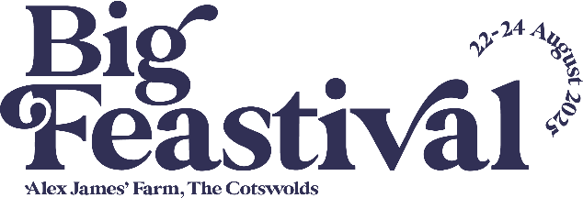

Getting Here Guide
Where is Big Feastival?
Alex James’ Farm in Kingham
Oxfordshire
OX7 6UJ
Please ensure you follow YELLOW AA signage rather than your Sat Nav as you become closer to the event site to ensure you do not experience any difficulties.

By Train:
The nearest train station is Kingham. The train station is 0.2 miles / 0.3 km from Big Feastival.
The closest railway station is Kingham, which is only a 3-minute walk to the festival site. From London Paddington, it is approx 90 mins to Kingham, with regular trains also running to and from Oxford, Reading, Worcester and Hereford.
Train schedules and tickets will be released three months before the festival. Visit www.gwr.com to secure your seats.

By Taxi:
There will be a pickup & drop point for Taxis at the Red Gate to the festival.
- Local taxi numbers are below:
- Blenheim Taxis - 07773 000444
- Byeways Taxi – 01451 844384
- Courtesy Cars – 01608 641510
- Excelsior Taxis – 01608 643721 (taxis / minibus)
- Hasan Taxi – 07903 740131
- North Cotswold Taxis & Tours – 07832 915871
- Snips – 07930 937564

How to book Blue Badge parking

For more information on how to book Blue Badge Parking, please see our step-by-step guide below:

- To book Blue Badge parking for Big Feastival please follow this link: https://thebigfeastival.com/tickets
- Please select your chosen ticket type for the festival to proceed to the next page. For help deciding what tickets you need, please visit our ticket guide on our FAQs.
- If you are camping in our Access Campsite, please select the Access Camping Parking under the ‘Access Camping’ tab.

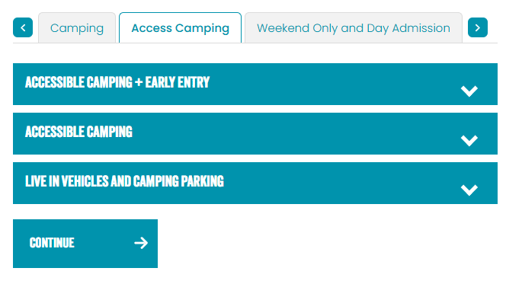
- If you are attending for the Day (Weekend or Day tickets), please select the relevant Blue Badge parking under Parking on the ‘Weekend Only and Day Admission’ tab (image below).
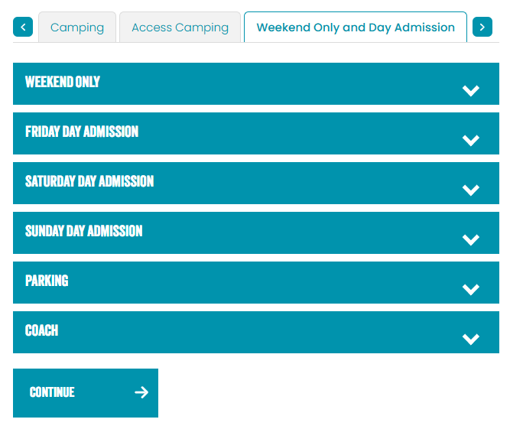

- Proceed to checkout
- You will need to upload a copy of the relevant documentation when prompted on checkout. This includes:
- Copy of DLA, PIP or Adult Disability Payment entitlement letter
- Evidence of registered severely sight impaired (blind)
- CredAbility Access Card (with +1 icon)
- Copy of Attendance Allowance letter
- Recognised Assistance Dog ID card
- A current and valid blue badge
- Any other relevant documentation

If you have any queries, do contact our team who will be able to assist: https://help.thebigfeastival.com/hc/en-gb/requests/new

